Week 3:

Classification and Representation
- Logistic Regression Model:
  - Cost function:
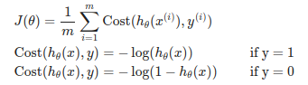
- Multiclass Classification
  - One-vs-all
- Solving the problem of Overfitting
  - Reduce number of feature
  - Regularization
    - Keep all the features, but reduce the magnitude of parameters
- Regularization Linear Regression
- Regularization Logistic Regression

